Physiotherapy Placements in Social Care
Making the most out of your placement opportunities
Nursing and residential homes

23rd January 2023


(CSP, 2020)


Clinical Placements Expansion Programme
By Lauren Smith

Introduction

This guide will help to give you an understanding of the role of a physiotherapist within residential and nursing homes, and how to make the most out of your placement opportunities.
Placement expansion enables students to work in a diverse range of settings and access rich learning opportunities for the future physiotherapy workforce. As populations are ageing and often more medically complex, a broad range of skills are needed across all settings. This includes assessing and diagnostic skills, behaviour change techniques, delivering advice and education, collaborating with integrated teams, using innovative healthcare technologies and influencing change. Exposure to these skills as a student could unlock amazing learning potential, as well as allow more people to access physiotherapy, influence services and develop new roles for the workforce.
Social care services provide support to people with learning disabilities, physical disabilities or illnesses and mental illnesses. Services can include day services, nursing and residential homes, charities and respite.
This document will focus on Physiotherapy placements in residential and nursing homes.

Residential and Nursing Homes

Residential care homes offer 24-hour support for people who may be unable to live independently. Support provided includes assistance with tasks such as dressing, washing, eating and mobility. Residents may also be encouraged to engage in regular social and physical activity. Residents may have health needs which can be met by staff or visiting health professionals, but do not require medical care. Residential homes may provide support for both short and long term.
Nursing homes are similar to residential homes, but also provide care to people who require significant support with daily tasks, or who require regular medical treatment. They are able to provide a higher level of care, and are sometimes specialised e.g. for dementia or neurological conditions.

The role of a Physiotherapist

Physiotherapists’ are often involved in the multidisciplinary care of residents within residential and nursing homes.
Physiotherapists’ provide care for a range of specific and complex issues including musculoskeletal, neurological and respiratory issues, frailty and functional decline.
The aims of physiotherapy in this setting may include promoting physical activity, providing rehab to regain independence with mobility and activities of daily living, continuation of rehab following hospital discharge, applying safe manual handling techniques, assessment and prescription of mobility aids, assessment and reduction of falls risk, rehab post-surgery or injury, pain management, develop confidence and quality of life, increase strength, improve balance and gait re-education.
Wider roles may also include liaising with multi-disciplinary teams within and external to the service, contributing to residents care plans, attending meetings, signposting to other services or making onward referrals and providing advice and education to the individual, staff and families.
(CSP, 2021)

Residents

Each resident will have varied medical histories which may be complex and multi-factorial. This will allow you to draw upon a wide variety of knowledge and skills. Some examples may include:
- Neurological – Parkinson’s and previous stroke
- Cardiorespiratory / Vascular – COPD, previous myocardial infarctions and other cardiac diseases, diabetes
- Orthopaedic – recent trauma e.g. fractures, surgery e.g. total hip or knee replacements, amputees, osteoarthritis, rheumatoid arthritis
- Mental health disorders such as dementia or delirium
- Palliative / end of life care

Opportunities

Undertaking a clinical placement in social care will give you the opportunity to:

Working within residential and nursing homes will give you a unique experience working with a large variety of internal and external MDT staff. These may include:

Examples of opportunities with reference to the Common Placement Assessment Form:
Please note, these are purely examples of potential ways to meet CPAF domains and criteria. Each placement will differ, and you are encouraged to seek opportunities relevant to the placement setting in alignment with your learning needs.
 | Domain | Opportunities
1 | Independent learning | Research of relevant guidelines and evidence, engaging in reflective practice, seeking opportunities within the service, utilising personal development plan.
2 | Seeking reflecting on and responding to feedback | Seeking feedback from service staff, supervisors and service users. Engaging in individual reflections. Demonstrating changes to practice post-feedback/reflection.
3 | Organisation and prioritisation | Organisation and prioritisation of caseload around service-user needs and service activities. Planning of MDT observations and collaborations.
4 | Communication | Adapt, modify and develop verbal and non-verbal communication for residents, families/carers, service staff and MDT. Consider communication tools to ensure effective communication with those with impairments e.g. cognitive, speech, sight, hearing. Communicating via documentation of clinical notes or exercise plans.
5 | Working with others | MDT observation and collaboration. Demonstrate understanding and scope of physiotherapy roles and wider service roles to meet holistic needs of service users.
6 | Individuals, Communities, Populations | Demonstrate understanding of health inequalities, funding streams, post code lotteries, current affairs, inclusion and non-discrimination, inclusive approach to relationships with staff and residents. Leadership and service improvements e.g., group classes. Develop understanding of mental health and holistic individual considerations. Understand the impact of these issues on practice and treatment for service users.
7 | Gathering and Analysing Information | Gathering information from guidelines, evidence, service staff, MDT and service users to inform assessment and treatment plans.
8 | Evidence Based Practice | Demonstrate understanding and application of relevant guidelines and up to date evidence to inform assessment and treatment plans. Apply suitable approaches or changes to practice.
9 | Reasoning and Intervention | Demonstrate reasoning of appropriate interventions by utilising information from assessments and outcome measures. Use of SMART goals. Apply relevant and safe interventions, appropriate to the needs of the service user and monitor effectiveness. Adapt interventions as necessary.
10 | Recording Information | Documentation of clinical notes, handover of information, treatment plans and reflections.

Project Ideas

Below are two examples of projects which could be undertaken in a residential or care home setting.

Falls risk screening

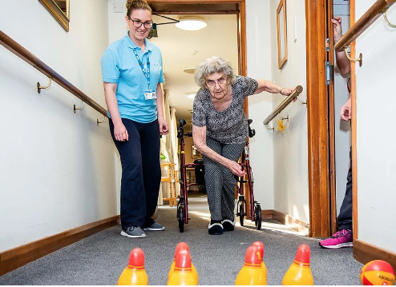

(CSP, 2020)
Group exercise programme
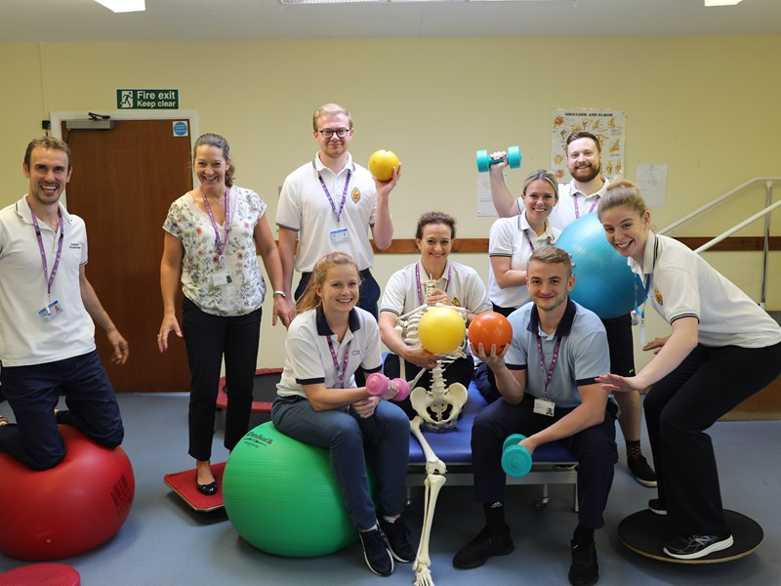
NHS (2023)

Support

Whilst on placement there will be a wide range of people available to support you. This includes:
- Named educator or supervisor: Will provide support throughout the placement and is responsible for co-ordinating the assessment process, although other members of the team are likely to contribute to both formative and summative feedback.
- Service management and staff: Will provide service and resident-specific support.
- University placement tutor: Will provide profession-specific support.
Your named educator or supervisor, university placement tutor and a named member of the service will be key points of contact for any support needs, questions, issues or concerns.
- Personal university tutor: Your personal university tutor can provide additional support if needed.

Resources

Below are some example resources to underpin knowledge and understanding of working with older people:
- AGILE is a Professional Network of the Chartered Society of Physiotherapy and is for therapists working with older people: https://agile.csp.org.uk/

- The British Geriatrics Society is the membership association for professionals specialising in the healthcare of older people across the UK: https://www.bgs.org.uk/

- NICE guidelines, evidence and recommendations for older people: https://www.nice.org.uk/guidance/population-groups/older-people

- NHS information around social care services and care homes: https://www.nhs.uk/conditions/social-care-and-support-guide/care-services-equipment-and-care-homes/care-homes/

- Chartered Society of Physiotherapy information around physiotherapy for older people: https://www.csp.org.uk/networks/associates-support-workers/clinical-knowledge-development/older-people

