User Guide

Contents:-

1. Becoming a member
2. Your Profile
3. Booking onto a course
4. Feedback and Certificates
5. Forgotten password
6. Becoming a member

Go to [www.learninganddevelopmentcentre.co.uk](http://www.devontraininghub.co.uk) and go to join now



Find your organisation by typing your Practice name into the Organisation Search. If your practice does not show up please click the button below and fill out the details of your organisation.

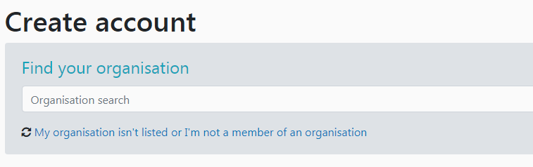

Ensure you fill in:

* Email Address
* Job Role from the options by clicking the appropriate box. If your job role is different please fill out the other box with your job role
* Password – twice
* Title
* First Name
* Last Name
* Primary Contact Number – This will only be used to if there is a change to a course you are booked onto so please make sure it is a number we can contact you on.
* Any access or dietary requirements – many of our courses provide lunch and refreshments so please make sure this is filled in correctly.

Select one of the 2 account types:

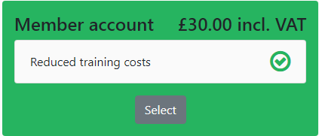Member account - to gain full access to discounted course’s. for the cost of £30 inc VAT you will have the benefit of half price course. (in most cases of a paid for course you will benefit by at least £30 therefore we would recommend becoming a member if you want to attend any paid courses.

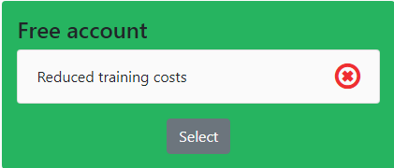

Free Account – this is for those people wishing to attend free courses only. If you try to attend a paid for course you will be charged at non-members rates.

Agree to terms of use

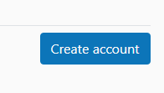

Then click –

You will then have created your account.

1. Profile

Under your name, when you are logged in, you will find a dashboard option:

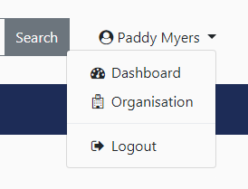

Click onto your dashboard and you will see another menu:

* Membership – Shows your membership plus the date the membership runs out
* Organisation – indicates which practice you are assigned to
* Training Hub – lists any training you have attended or are booked on
* Profile – your personal details, you can amend any changes here
* Invoices – see any invoices outstanding (you can also download any invoices visable as PDF’s)
* Privacy & Settings – normal privacy settings

1. Booking onto a course

On the main site [https://www.learninganddevelopmentcentre.co.uk/](https://www.devontraininghub.co.uk/) click on the Courses and events section.

You can then use the course finder on the right hand side of the page to find what you are looking for.

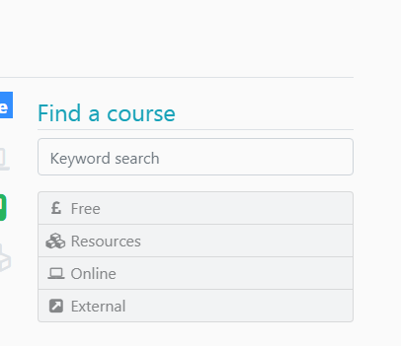

Once you have found the course you would to be on, select the course

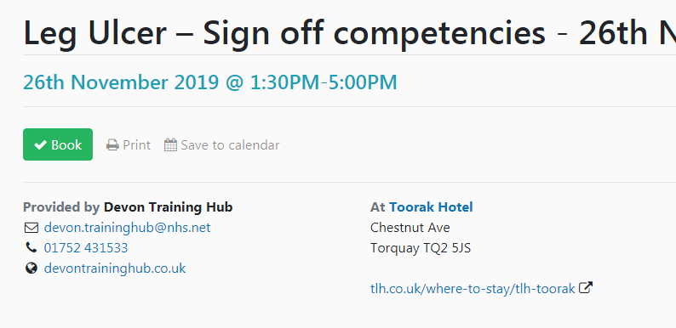

Click the green ‘Book’ Button

Click the Blue Book button above the Terms and Conditions and Cancellation Policy for a free course

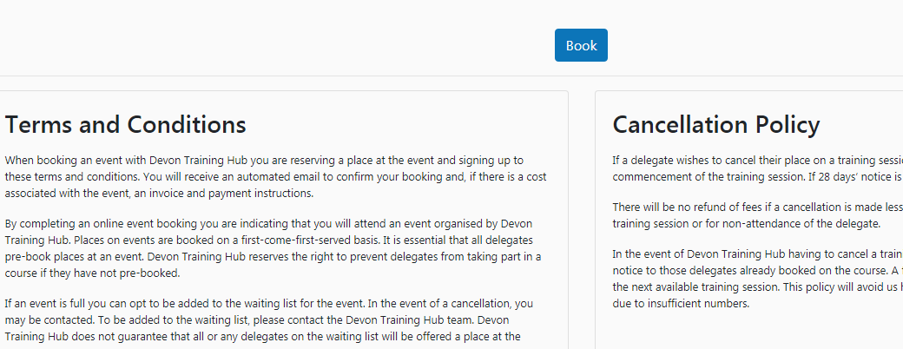

If the course has a cost associated you can either pay by card, or select for an invoice to be sent by choosing from the options shown below and pressing the blue book button

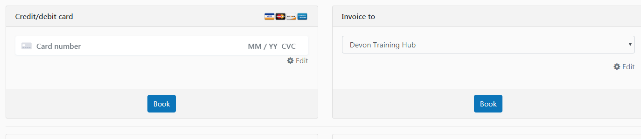

1. Feedback and Certificate

Once you have attended a course please keep an eye out on your email account (the one assigned to your account – please also check your junk mail folder in case the emails are in this folder)

Please follow the instruction on the email – for information these instructions are shown below.

* Please now Log into your account on the website
* Under your name a drop down menu will appear
* Click on dashboard
* Click on Training Hub
* You will then see the courses you have booked on and attended; click on the green star next to the course name to download your certificate.

1. Forgotten Password

If you forget your password please click on the lost password? Button at the bottom of the login page,

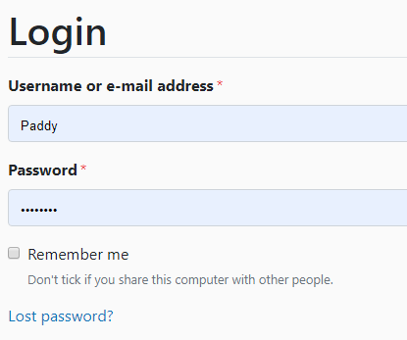

We hope you found this guide useful, if you need any further information or are unsure whether you have already set up your account please do not hesitate to phone the team on 07780 901 637

Or email us on [ldc.sentinel@nhs.net](mailto:ldc.sentinel@nhs.net)