**Stories from the end of life**

**South West Palliative Care Research Network**

**Who are we and what are we doing?**

A group of people from 7 hospices, 4 universities and various community and health organisations across SW England that want to improve people’s experiences at end of life.

We wanted to find out the views and feelings of people living in rural and coastal areas, and those living on a low-income, about what is needed to enable living well, dying well, and grieving well. Understanding this will help to develop the right kinds of support, and future research, to better meet people’s needs.

**Our aims**

We spoke to people from different rural, coastal and low-income communities to find out

* What issues are important to people when they think about death and dying?
* Are there issues particularly related to being in rural, coastal and low-income communities that affect people’s experiences when they have a life-limiting illness, or that affect their families or carers?
* What information do people find useful and what kinds of support are people seeking?
* How accessible, useful and relevant do people find the resources and services available locally?

**How did we find out?**

From January to September 2022 we gathered people’s views and experiences, using four different methods:

1. **Departure Lounge**

We took ‘The Departure Lounge’, a pop-up installation about end of life, into nine different settings, including community cafes, community groups, a health centre, charity shops. We had conversations and shared information with people who were interested in talking about their experiences and thoughts.

1. **Community Conversation suitcases**

Torbay Communities and Filament worked together to create a ‘Community Conversation suitcase’ - a tool containing different creative activities and prompts to help facilitate conversations. The suitcases were used by Community Connectors to have conversations with individuals in their own homes. People took part who had experience of living with, or caring for someone living with, a life-limiting illness.

**If you work within the community, or a healthcare service, and would like to trial using the Community Conversations suitcases with community members, please get in touch. We would be delighted to loan the resource in return for some brief feedback.** Contact Amanda Lynn, Community Builder Lead Coordinator, Torbay Communities [amandalynn@torbaycdt.org.uk](mailto:amandalynn@torbaycdt.org.uk) .

1. **Real stories from the end of life**

Storyteller Sara Hurley worked with three participants to explore their experiences in more depth and co-create a story for each person. This moving collection illustrates a range of experiences – see the display, and follow the QR code to listen to the stories in your own time and feedback.

**We are now considering how these stories could be used, for example for training health and social care professionals, or to advocate for better support services. If you have any thoughts, ideas or suggestions for how these stories could be used, or would like to use them with your work / organisation, please let us know using the webpage link on the flyer.**

1. **Focus Groups**A researcher from Exeter University (Lorraine Hansford) ran 4 focus groups within community settings, to discuss in more depth the issues and themes that had been raised.

**What did we learn?**

We gathered together the information that people told us about their experiences of living, dying and grieving in the south west; the findings are available in the report available if you leave contact details.

People expressed their views about the difficulty of accessing healthcare, support and information. They explained what support was important to them, and described the role that communities can play in supporting people at end of life.

**What next?**

The findings are helping us to decide on areas of research that are important for the future, to address the needs identified by communities. Individual organisations within the network are also using the findings from the research to help shape their services. The South West Palliative Care Research Network was funded to run for 15 months by the National Institute for Health Research. Member organisations (listed below) are continuing to meet to discuss opportunities for future joint research opportunities.

This project was funded by the National Institute for Health and Care Research Palliative and End-of-life Care Research Partnerships programme. See the NIHR Journals Library website for further project information.

**SW Palliative Care Research network: Member organisations**

*The organisations involved in the partnership were:*

Cornwall Hospice Care

Devon & Cornwall Police

Health Watch Devon, Plymouth & Torbay

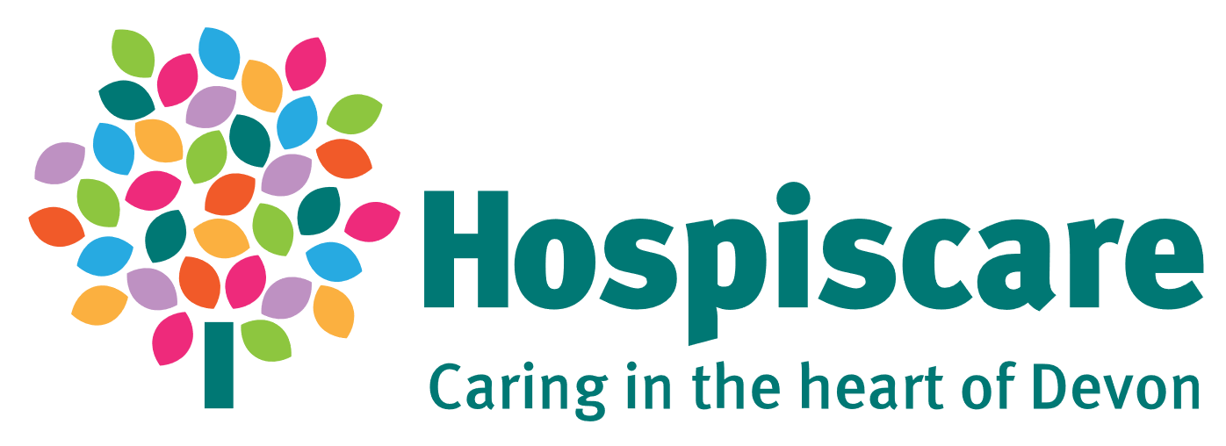Hospiscare

King’s College London

Marie Curie

North Devon Hospice

NIHR Clinical Research Network South West Peninsula

NIHR Research Design Service South West

Plymouth Octopus Project

Rowcroft Hospice

SWP Palliative Care Research Partnership Patient and Public Involvement group

St Luke’s Hospice

St Margaret’s Hospice

Torbay Communities

University College London / St Christopher’s Hospice

University of Exeter

University of Plymouth.

