Social Care Fellowship
Discovery Workbook

Overview of Discovery Workbook

This workbook is a tool to help you on your fellowship journey by recording the information you have learned through all stages of the project. It helps you as a fellow to write down findings and ideas through the design thinking process of your individual project.

Write in your workbook often and give yourself time to reflect on actions you have taken and how your project is progressing.

When the project is finished, the workbook will illustrate your journey but also help us to review your progress, what difficulties you encountered and create effective action on how you can enhance your knowledge of applying tools and techniques.

.

Fellow Name:
Project Mentor Name:
Project Name:

Design Thinking Framework

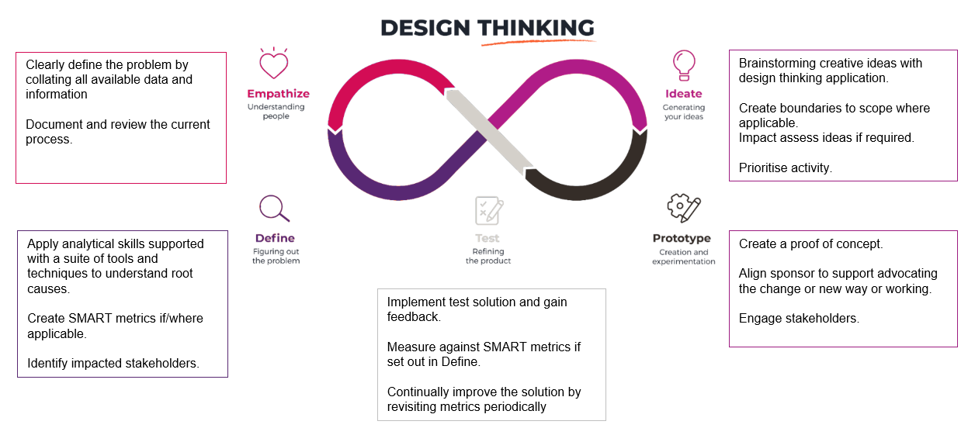

Empathise
Clearly define the problem by collating all available data and information
Document and review the current process.
Tools | Stakeholders
- Process Mapping | List those who will need to be engaged

Action Log
Action | Owner | Target Date

Risk Log
Risk Description | Risk Owner | Action to Resolve | Target Resolution Date

Empathise Output
Document all activity undertaken

Define
Apply analytical skills to understand root causes.
Create SMART metrics if/where applicable.
Identify impacted stakeholders.

Tools | Stakeholders
- Fishbone  - 5 Why’s | List those who will need to be engaged

Action Log
Action | Owner | Target Date

Risk Log
Risk Description | Risk Owner | Action to Resolve | Target Resolution Date

Define Output
Document all activity undertaken

Ideate
Brainstorming creative ideas with design thinking application.
Create boundaries to scope where applicable.
Impact asses’ ideas if required.
Prioritise activity.

Tools | Stakeholders
- Round Robin  - Project Scoping In/Out Tool | List those who will need to be engaged

Action Log
Action | Owner | Target Date

Risk Log
Risk Description | Risk Owner | Action to Resolve | Target Resolution Date
Ideate Output
Document all activity undertaken

Prototype
Create a proof of concept.
Align sponsor to support advocating the change or new way or working.
Engage stakeholders.

Tools | Stakeholders
- Process Mapping | List those who will need to be engaged

Action Log
Action | Owner | Target Date

Risk Log
Risk Description | Risk Owner | Action to Resolve | Target Resolution Date

Prototype Output
Document all activity undertaken

Test
Implement test solution and gain feedback.
Measure against SMART metrics if set out in Define.
Continually improve the solution by revisiting metrics periodically

Action Log
Action | Owner | Target Date

Risk Log
Risk Description | Risk Owner | Action to Resolve | Target Resolution Date

Test Output
Document all activity undertaken

Summarise your project findings
- What went well?
- What you could do more of to get better outcomes?
- What were the challenges?

What went well | What could you do more of? | What were the challenges?

Additional Comments
- Feedback from stakeholders?

